MODELO DE DATOS

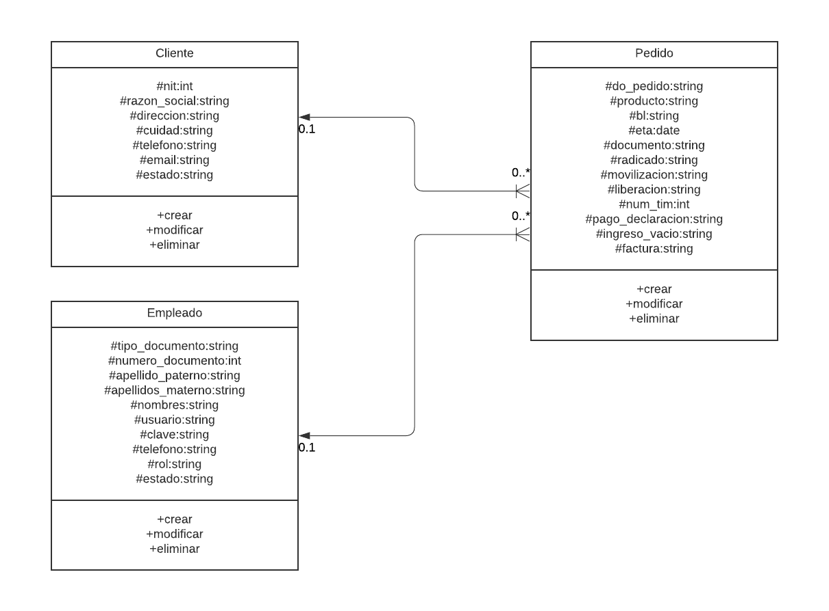

<https://lucid.app/lucidchart/edbac5e3-d25b-447c-8722-26fccb8c63ac/edit?viewport_loc=-1061%2C-492%2C4096%2C1828%2C0_0&invitationId=inv_ec482d4f-e0fc->

MODELO DE E-R

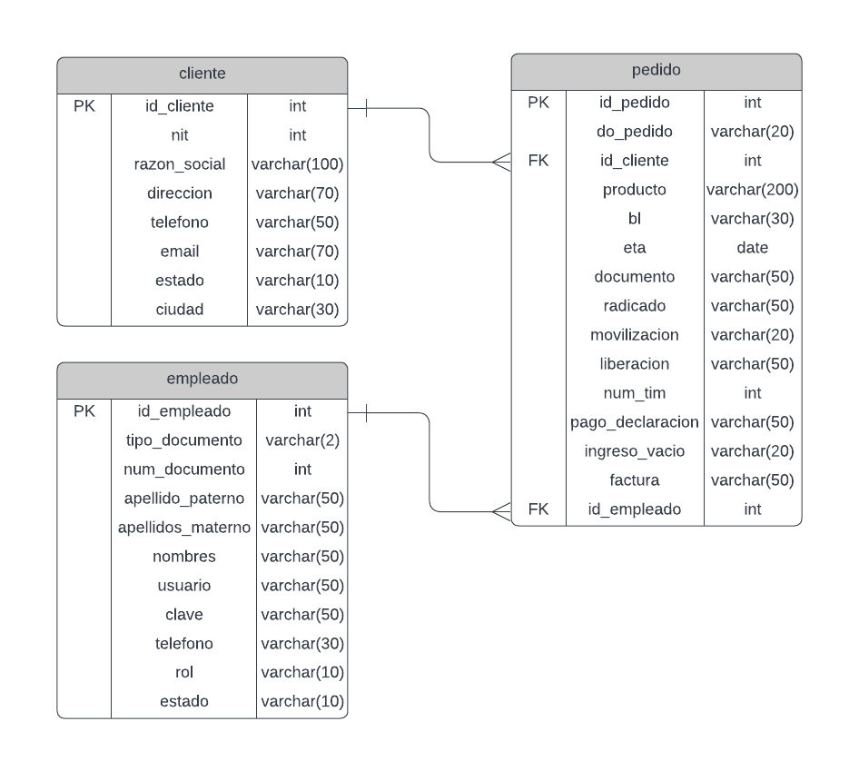

<https://lucid.app/lucidchart/b9c540d8-980b-44fd-a7ee-2c51871e4e60/edit?viewport_loc=-183%2C200%2C2223%2C992%2CHWEp-vi-RSFO&invitationId=inv_338e4d1d->